Screening Kit
Spring is Goose: Preparing the Next Generation of Cree Harvesters in Churchill, Manitoba

This toolkit supports project partners or interested groups and individuals share Spring is Goose at a public or private screening.

Film Information
Spring is Goose: Preparing the Next Generation of Cree Harvesters in Churchill, Manitoba
Prepared for Oceans North by Always Build Studios
Run time:
Official film website HERE
STREAM the trailer | STREAM the full film | DOWNLOAD the full film

Overview
For the Cree of Manitoba, goose hunting is foundational to culture, livelihoods, nutrition, and the retention of traditional knowledge.
Each spring, Food Matters Manitoba supports Indigenous youth, from across the province, as they travel to Churchill for the annual harvest. There they are mentored by experienced hunters as they harvest and process food to bring back to their communities.
In 2025, Oceans North travelled to Churchill to document the hunt and celebrate the annual tradition as a way of maintaining connection to, and knowledge of, the lands, waters, and culture.

Tech Checklist
Screening Spring is Goose may require:
- Laptop computer
- USB-C to HDMI adapter
- Projector & screen
- Speakers and audio cable
- Internet connection

Promotional Resources
Social media copy and assets that can be used to promote your screening:
For the Cree of Manitoba, goose hunting is foundational to culture, livelihoods, nutrition, and the retention of traditional knowledge.

Each spring, Food Matters Manitoba supports Indigenous youth, from across the province, as they travel to Churchill for the annual harvest. There they are mentored by experienced hunters as they harvest and process food to bring back to their communities.

In 2025, Oceans North travelled to Churchill to document the hunt and celebrate the annual
tradition as a way of maintaining connection to, and knowledge of, the lands, waters, and culture.

🍿 Join us for a viewing of Spring is Goose: Preparing the Next Generation of Cree Harvesters in Churchill, Manitoba.

[DATE/TIME]
[LOCATION]
[ADDITIONAL DETAILS]

Film produced by Oceans North and Food Matters Manitoba

#CreeHarvesting #ChurchillManitoba #GooseHunting #FilmPremiere

NOTE: You can tag @oceans_north (Instagram), Oceans North (LinkedIn), @Oceans North (Facebook) for additional reach.

See here a copyright-free media library to pull visual assets in support of social media/web promotion. Please credit all images to Oceans North
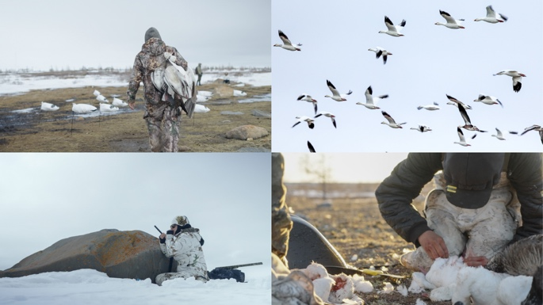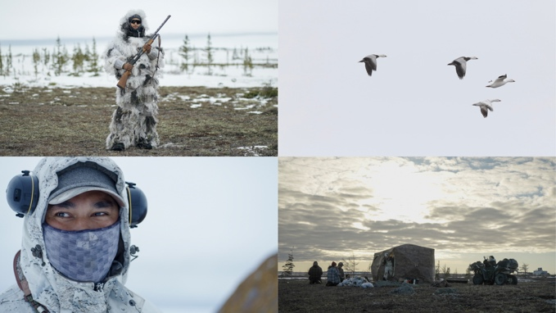

Questions?
Please contact Aaron Janzen (ajanzen@oceansnorth) or Morgan McCurdy (morgan@foodmattersmanitoba.ca) with any questions or concerns.

About Oceans North
Oceans North supports marine conservation & climate action in partnership with Indigenous and coastal communities. We develop programs and policies to address the threats facing northern marine ecosystems by listening, learning, and understanding the unique challenges facing the communities where we work.

About Food Matters Manitoba
Food Matters Manitoba is a Winnipeg-based organization partnering with Manitoban communities to create sustainable food systems rooted in social justice.

